Largest Known Primes
# Source: AI Source: Provided by: [Data Path: Persons Table -> ID Column: 1, Name_En Column: Motasem Essam] -> From: [ChatGPT] on [7/13/2026]
The largest known primes are the greatest prime numbers that have been discovered and verified at a given point in time. Because there is no largest prime number (Euclid proved that infinitely many primes exist), this title changes whenever a larger prime is discovered.
Today, the largest known primes are almost always Mersenne primes, numbers of the form
$$2^{p}-1,$$
where $p$is itself a prime number.
The search for the largest known primes is an active area of computational number theory and is carried out by large distributed computing projects.

Definition
# Source: AI Source: Provided by: [Data Path: Persons Table -> ID Column: 1, Name_En Column: Motasem Essam] -> From: [ChatGPT] on [7/13/2026]
A largest known prime is the greatest prime number that has been discovered and verified at a particular time.
Since infinitely many primes exist, there is no final largest prime. The title simply belongs to the largest one currently known.

Euclid's Theorem
# Source: AI Source: Provided by: [Data Path: Persons Table -> ID Column: 1, Name_En Column: Motasem Essam] -> From: [ChatGPT] on [7/13/2026]
Around 300 BCE, Euclid proved that there are infinitely many prime numbers.
Therefore,
- there is no largest prime number, and
- there will always be larger primes waiting to be discovered.

Mersenne Primes
# Source: AI Source: Provided by: [Data Path: Persons Table -> ID Column: 1, Name_En Column: Motasem Essam] -> From: [ChatGPT] on [7/13/2026]
Nearly every modern record prime is a Mersenne prime, having the form
$$2^{p}-1,$$
where
- $p$is prime, and
- $2^{p}-1$is also prime.
These primes are preferred because they can be tested efficiently using the Lucas–Lehmer primality test.

Rules for Largest Known Primes

1. The Number Must Be Prime
# Source: AI Source: Provided by: [Data Path: Persons Table -> ID Column: 1, Name_En Column: Motasem Essam] -> From: [ChatGPT] on [7/13/2026]
The number itself must satisfy the definition of a prime number.

2. It Must Be Larger Than Every Previously Known Prime
# Source: AI Source: Provided by: [Data Path: Persons Table -> ID Column: 1, Name_En Column: Motasem Essam] -> From: [ChatGPT] on [7/13/2026]
A newly discovered prime becomes the largest known prime only if it exceeds all previously verified primes.

3. The Record Can Change
# Source: AI Source: Provided by: [Data Path: Persons Table -> ID Column: 1, Name_En Column: Motasem Essam] -> From: [ChatGPT] on [7/13/2026]
Whenever a larger prime is discovered and verified, it becomes the new largest known prime.

4. Most Record Primes Are Mersenne Primes
# Source: AI Source: Provided by: [Data Path: Persons Table -> ID Column: 1, Name_En Column: Motasem Essam] -> From: [ChatGPT] on [7/13/2026]
Since the 1950s, almost every record prime has been a Mersenne prime because they are much easier to test than general large integers.

5. There Is No Largest Prime
# Source: AI Source: Provided by: [Data Path: Persons Table -> ID Column: 1, Name_En Column: Motasem Essam] -> From: [ChatGPT] on [7/13/2026]
The phrase largest known prime refers only to the largest currently discovered prime, not to a mathematical maximum.

Current Largest Known Prime
# Source: AI Source: Provided by: [Data Path: Persons Table -> ID Column: 1, Name_En Column: Motasem Essam] -> From: [ChatGPT] on [7/13/2026]
As of the latest verified record, the largest known prime is
$$2^{136,279,841}-1,$$
which is the 52nd known Mersenne prime.
It has
41,024,320 decimal digits.
This prime was discovered in October 2024 by Luke Durant using the Great Internet Mersenne Prime Search (GIMPS) distributed computing project.

Some Historic Largest Known Primes
# Source: AI Source: Provided by: [Data Path: Persons Table -> ID Column: 1, Name_En Column: Motasem Essam] -> From: [ChatGPT] on [7/13/2026]
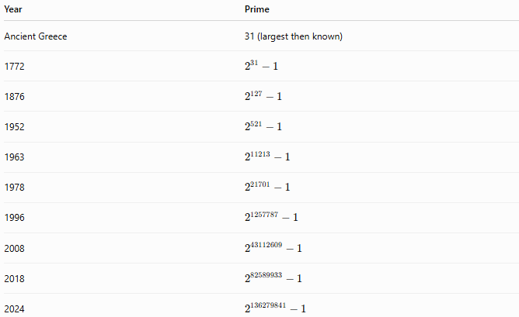
Year | Prime
Ancient Greece | 31 (largest then known)
1772 | $$2^{31}-1$$
1876 | $$2^{127}-1$$
1952 | $$2^{521}-1$$
1963 | $$2^{11213}-1$$
1978 | $$2^{21701}-1$$
1996 | $$2^{1257787}-1$$
2008 | $$2^{43112609}-1$$
2018 | $$2^{82589933}-1$$
2024 | $$2^{136279841}-1$$

Examples
# Source: AI Source: Provided by: [Data Path: Persons Table -> ID Column: 1, Name_En Column: Motasem Essam] -> From: [ChatGPT] on [7/13/2026]
Example 1
Is
$$2^{31}-1$$
a largest known prime?
It was the largest known prime after its discovery in 1772.
It is no longer the largest known prime today.

Example 2
Is
$$2^{127}-1$$
still the largest known prime?
No.
Although it is a Mersenne prime, much larger primes have since been discovered.

Example 3
Why isn't there a largest prime?
Because Euclid proved there are infinitely many prime numbers.
Therefore, for every prime, a larger prime exists.

Largest Known Prime vs. Largest Prime
# Source: AI Source: Provided by: [Data Path: Persons Table -> ID Column: 1, Name_En Column: Motasem Essam] -> From: [ChatGPT] on [7/13/2026]
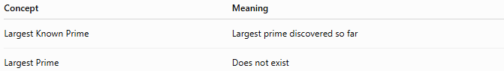
Concept | Meaning
Largest Known Prime | Largest prime discovered so far
Largest Prime | Does not exist

Real-Life Applications
# Source: AI Source: Provided by: [Data Path: Persons Table -> ID Column: 1, Name_En Column: Motasem Essam] -> From: [ChatGPT] on [7/13/2026]
The search for the largest known primes contributes to:
- Computational number theory
- High-performance computing
- Distributed computing
- Primality-testing algorithms
- Algorithm optimization
- Mathematical software
- Pure mathematics research
- Benchmarking computer hardware
Although record-sized primes are not directly used in practical cryptography, the algorithms developed to discover and verify them have influenced efficient primality testing and large-integer arithmetic.

Real-Life Examples
# Source: AI Source: Provided by: [Data Path: Persons Table -> ID Column: 1, Name_En Column: Motasem Essam] -> From: [ChatGPT] on [7/13/2026]
1. Distributed Computing
Projects such as the Great Internet Mersenne Prime Search (GIMPS) allow volunteers worldwide to contribute computing power in the search for new record primes.

2. High-Performance Computing
Searching for record primes stresses CPUs, memory, and numerical algorithms, making it a valuable benchmark for computing systems.

3. Algorithm Development
The search has led to significant improvements in fast Fourier transforms (FFT), large-integer multiplication, and primality-testing techniques.

4. Mathematical Research
Discovering larger primes helps researchers study the distribution and properties of extremely large prime numbers.

Common Mistakes
# Source: AI Source: Provided by: [Data Path: Persons Table -> ID Column: 1, Name_En Column: Motasem Essam] -> From: [ChatGPT] on [7/13/2026]
- Thinking the largest known prime is the largest possible prime.
- Assuming every large prime is a Mersenne prime.
- Confusing largest known with largest existing.
- Believing record primes are routinely used in encryption.
- Assuming the record never changes.

Key Points
# Source: AI Source: Provided by: [Data Path: Persons Table -> ID Column: 1, Name_En Column: Motasem Essam] -> From: [ChatGPT] on [7/13/2026]
- There is no largest prime number.
- The largest known prime is simply the largest prime discovered so far.
- Nearly all modern record primes are Mersenne primes.
- The current record prime is
$$2^{136,279,841}-1,$$
with 41,024,320 decimal digits.
- Record primes are discovered using large-scale distributed computing projects.

Largest Known Primes vs. Mersenne Primes
# Source: AI Source: Provided by: [Data Path: Persons Table -> ID Column: 1, Name_En Column: Motasem Essam] -> From: [ChatGPT] on [7/13/2026]
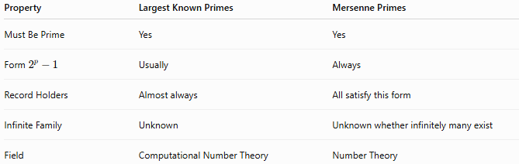
Property | Largest Known Primes | Mersenne Primes
Must Be Prime | Yes | Yes
Form $2^{p}-1$ | Usually | Always
Record Holders | Almost always | All satisfy this form
Infinite Family | Unknown | Unknown whether infinitely many exist
Field | Computational Number Theory | Number Theory

Largest Known Primes vs. Prime Numbers
# Source: AI Source: Provided by: [Data Path: Persons Table -> ID Column: 1, Name_En Column: Motasem Essam] -> From: [ChatGPT] on [7/13/2026]
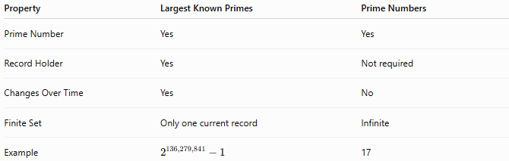
Property | Largest Known Primes | Prime Numbers
Prime Number | Yes | Yes
Record Holder | Yes | Not required
Changes Over Time | Yes | No
Finite Set | Only one current record | Infinite
Example | $$2^{136,279,841}-1$$ | 17

Conclusion
# Source: AI Source: Provided by: [Data Path: Persons Table -> ID Column: 1, Name_En Column: Motasem Essam] -> From: [ChatGPT] on [7/13/2026]
The largest known prime is the greatest prime number discovered and verified at a particular time. Because Euclid proved that infinitely many primes exist, there can never be a true largest prime number. Nearly all modern record primes are Mersenne primes, whose special form allows efficient testing using the Lucas–Lehmer test. As of the current record, the largest known prime is
$$2^{136,279,841}-1,$$
the 52nd known Mersenne prime, containing 41,024,320 decimal digits. The search for ever-larger primes continues to advance computational number theory, distributed computing, and high-performance algorithms.

